WEEK3_GATE3_ASSESMENT_DOCUMENTATION
ATHULDEV U

The Selenium Project Contain the following structure
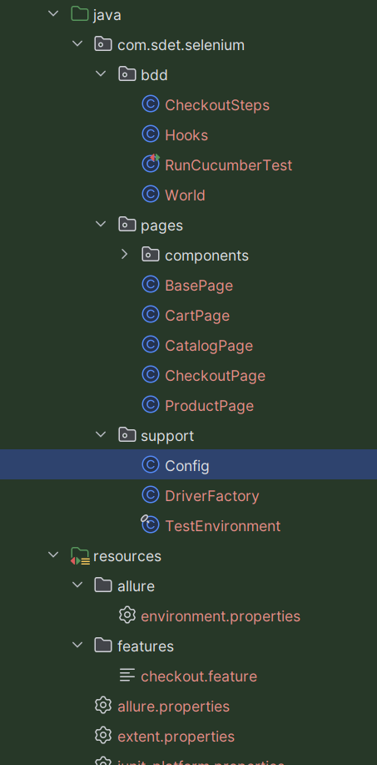
Bdd: contain files that are required for running cucumber test
Page: Pages contain components which has different fixed components and various pages in the website
support :Contain configuration of url and other details that describe how and where the test has to run
resources:It has allure properties and feature that contain Gherkin syntax also there are other junit configurations
The cucumber test flow like this:
Open Catalog Search ProductAdd productOpen CartChekoutOrderConformed message
Here there are different scenarios that have to be tested
1)Buy a single Product end to end
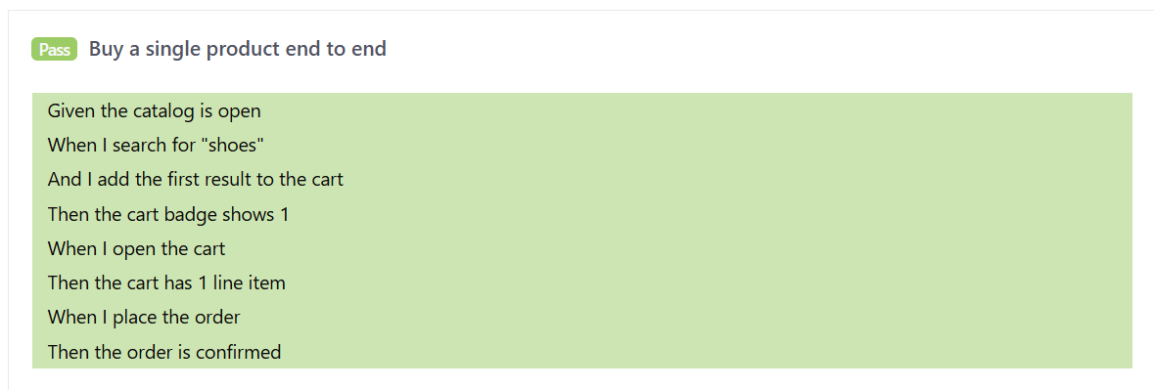
2)Buy different product end to end
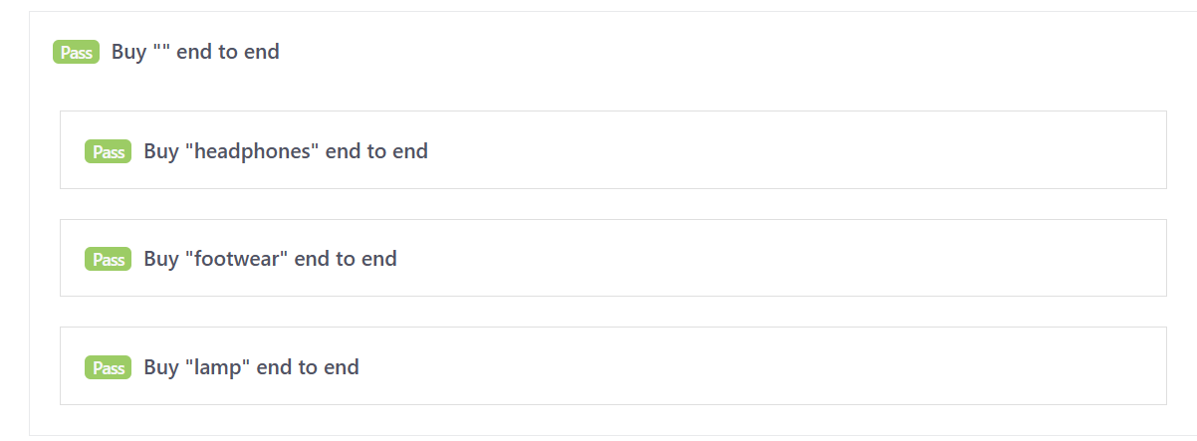
3)Show cart count
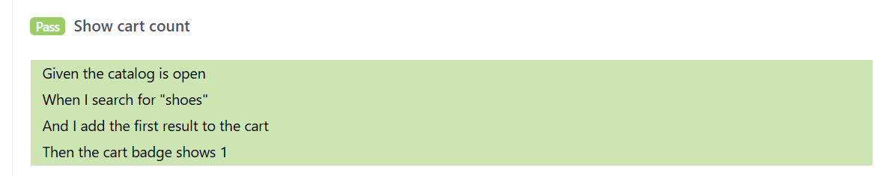
4)Fresh cart is empty
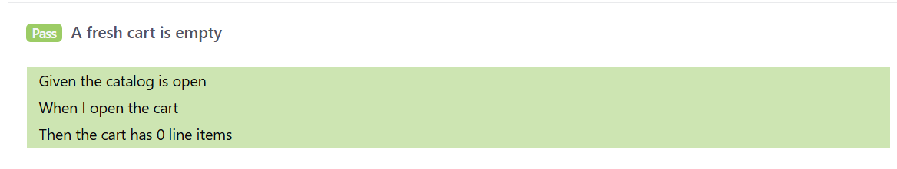

5)negative test(A fresh cart should be empty but here cart count 1 assertion is made)
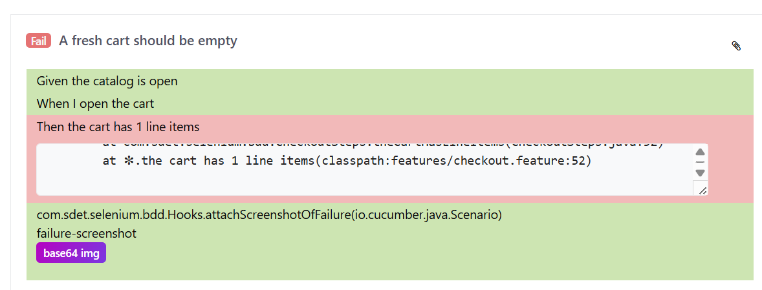
This test is put under the @negative tag that this test wont fail when we run the whole test. After change the cart count to 0 this test will Pass
screenshot
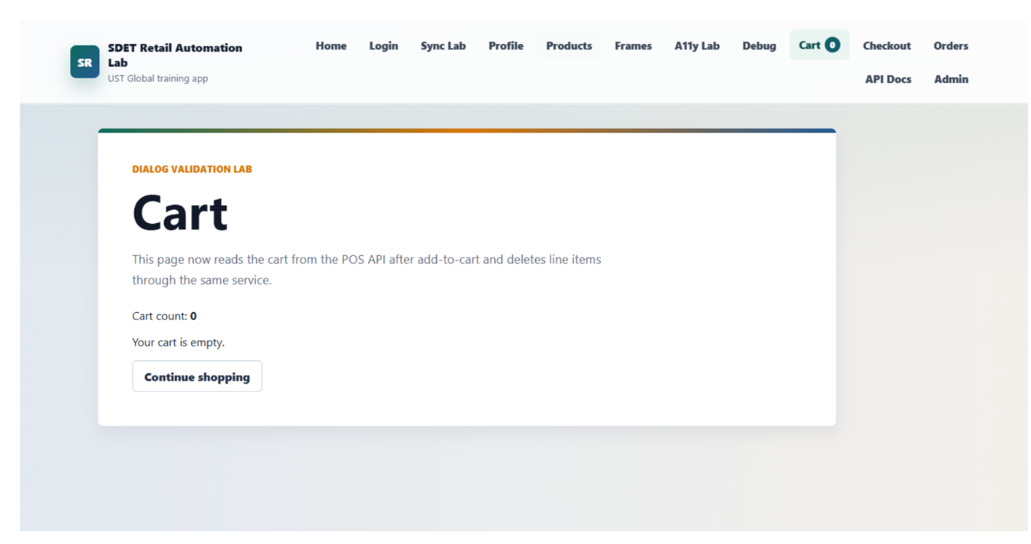
To run the test:
mvn test -Dtest=RunCucumberTest
The User Story for this test is:
I want to search for a product in catalog and add that product to my cart and
completete chekout so that i can buy what i come for so that team can prove the journey

